The range finder with alarm uses an ultrasonic sensor to detect distance. It lights consecutive Green, Yellow and Red LEDs as an object gets closer to the sensor. It sets of a speaker alarm at a minimum distance that can be reset by a button.

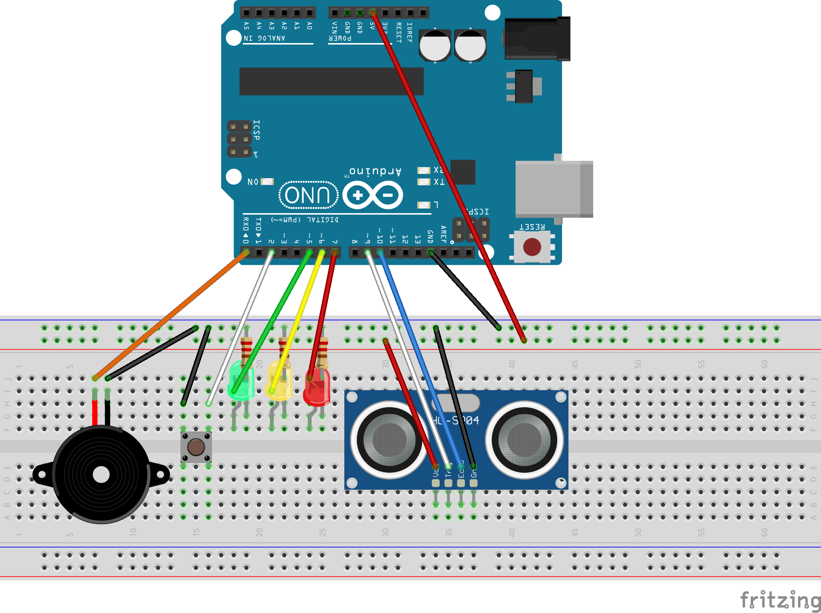

Example

* Distances less than 25in light the Green LED
* Distances less than 15in light both Green and Yellow LEDs
* Distance less than 10in light all LEDs and sound the alarm
* The button resets the alarm without changing the LEDs
* Moving the object or sensor more than 10in away from each other re-enables the alarm